Pandas Video - Part 3

About 19:00 min in

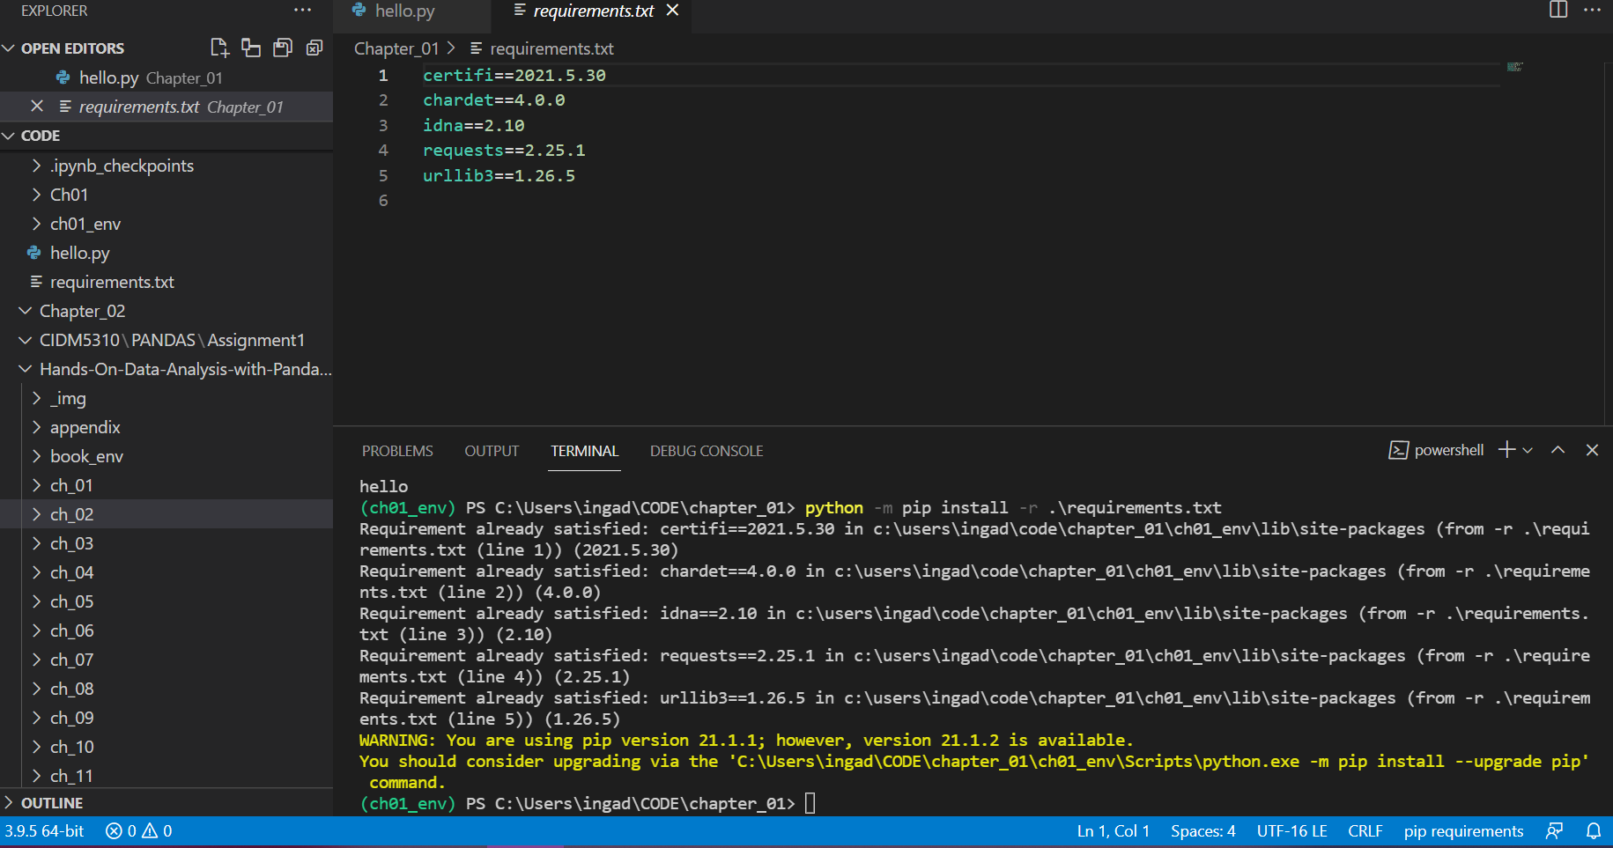

At 20:31: I do not have the .lib file that you were searching for to help Visual Studio Code find the virtual environment

CONCLUSION

USE THE BOOK_ENV as the virtual environment

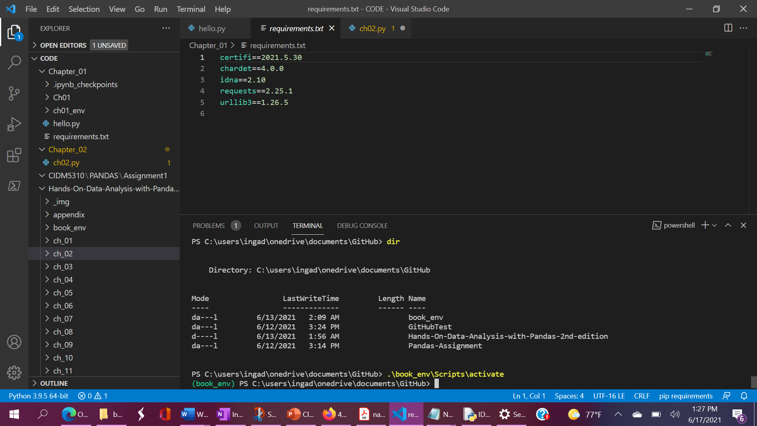

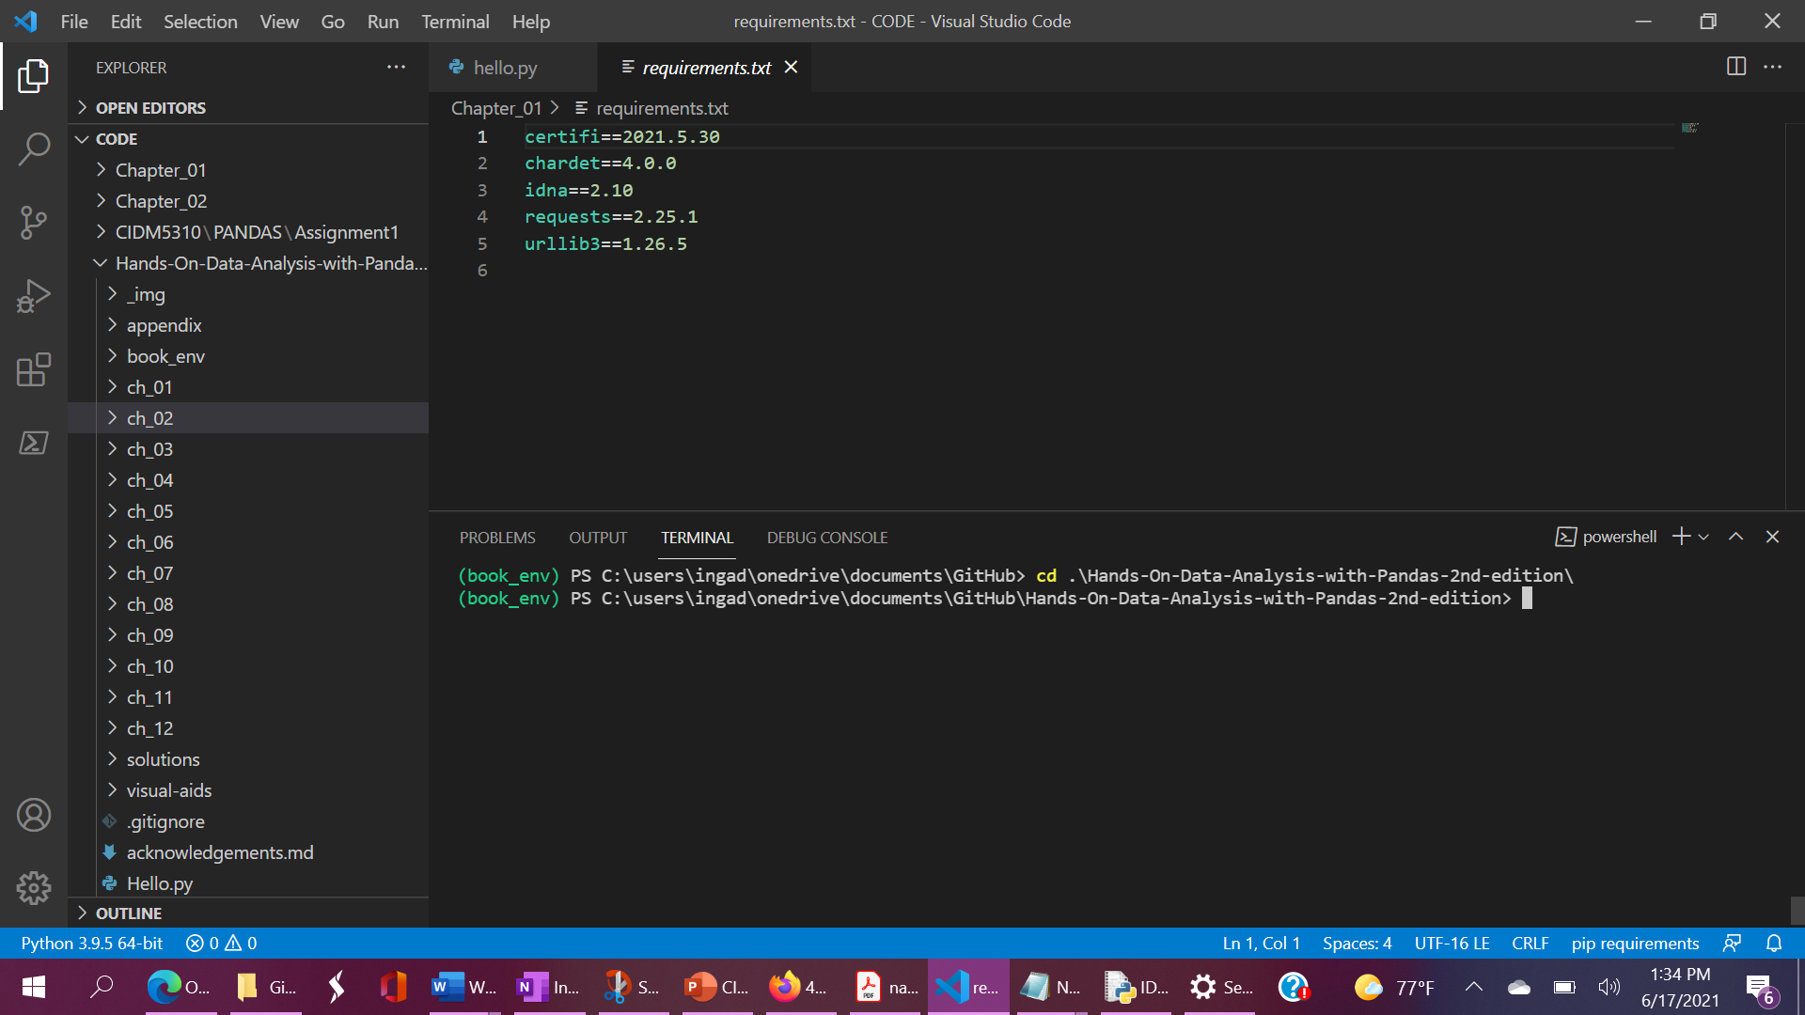

WAIT! USE THIS PATH AND VIRTUAL ENVIRONMENT –

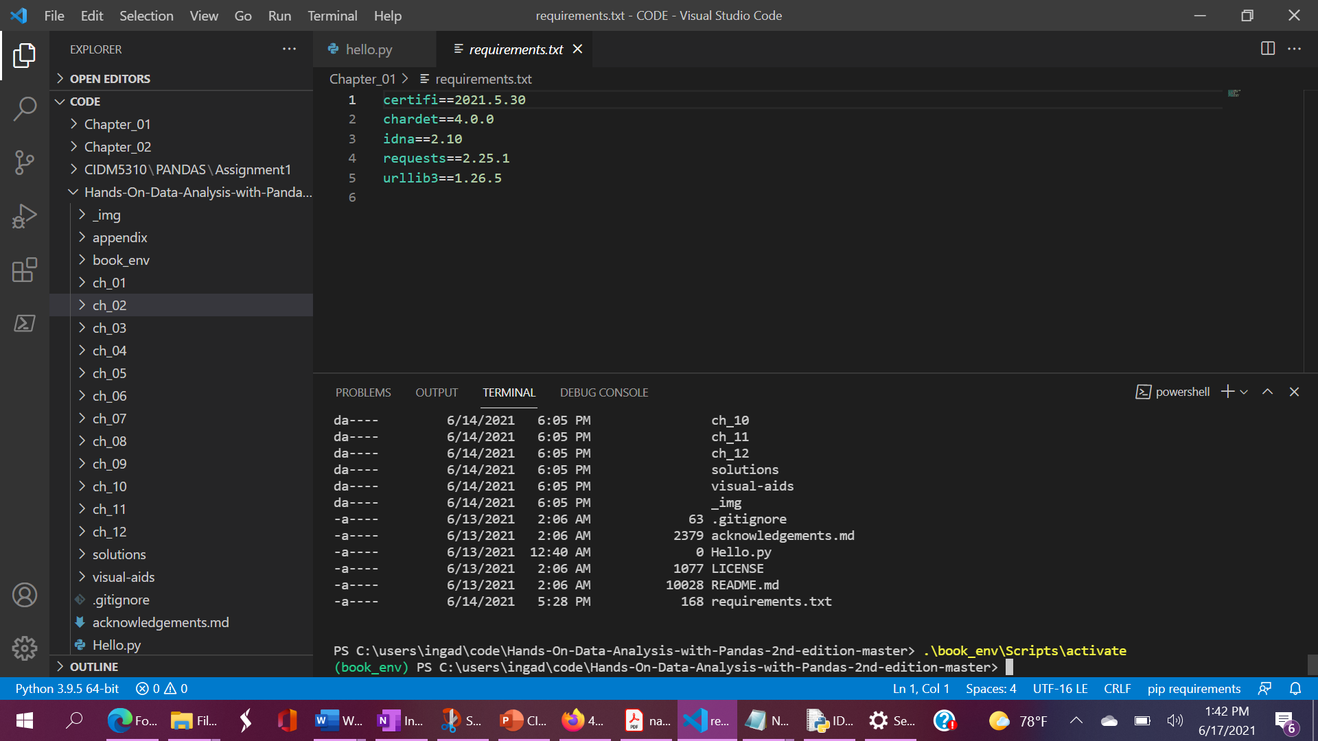

Run command:

python -m pip install -r .\requirements.txt

Results:

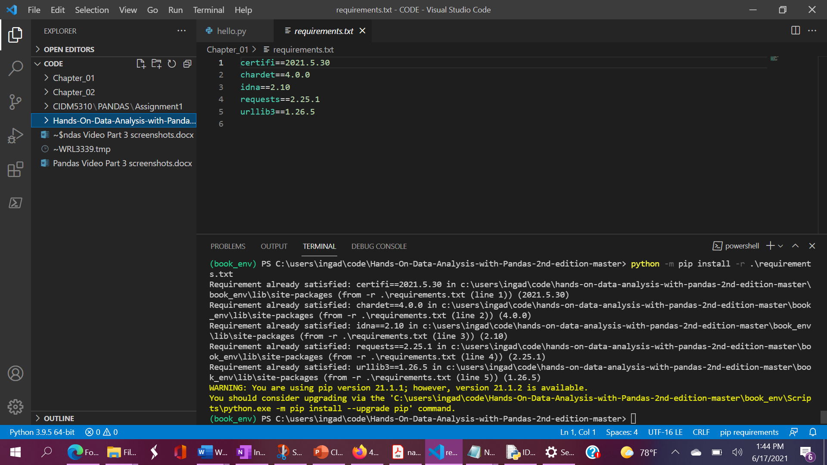

Had to change the requirements.txt file to match Dr. Babb’s screen

